Chapter 2 – Writing a C# Program

We will learn to create two basic types of applications in this chapter: a **console** application and a **desktop** application.

**\*\*Visual Basic Developer Settings applied – Visual C#\*\***

## Console App

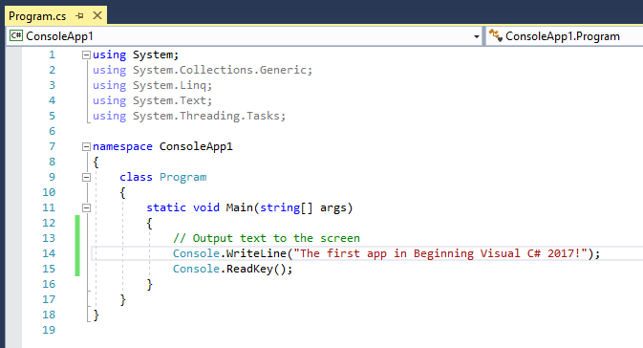



Console applications terminate as soon as they finish execution, which can mean that you don’t get a chance to see the results if you run them directly through the IDE (VS2017). To get around this in the preceding example, the code is told to wait for a key press before termination, using the following line: **Console.ReadKey();**

**Class View:** View > Class View – tab in Solution Explorer window.

The Solution Explorer view shows the files that make up the **ConsoleApp1** project. The file to which you added code, **Program.cs**, is shown along with another code file, **AssemblyInfo.cs**, and several references. ***Don’t worry about AssemblyInfo.cs at the moment.*** Other files can be contained within here that aren’t C# files like bitmap and sound files.

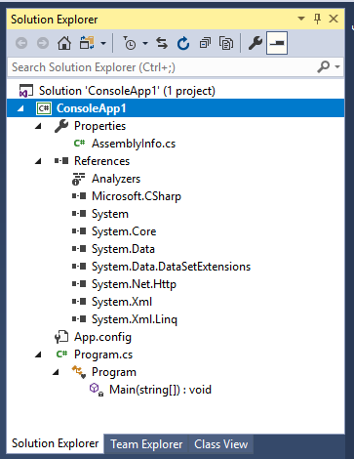

**Program.cs**  
This overview of your code structure can be very useful to enable you to navigate directly to specific parts of your code file, instead of opening the code file and scrolling to the part you want.

**References**  
Contains a list of the .NET libraries you are using in your project.

**Class View**  
Presents an alternative view of your project by showing the structure of the code you created.

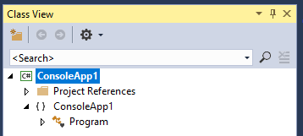

Desktop App

1. Created a new WPF App (.NET Framework) project.
2. Added a button control to the Mainwindow.xaml
3. Added the following highlighted code to that button

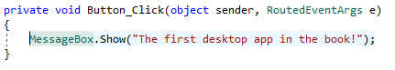

1. Here is the output when we run the application

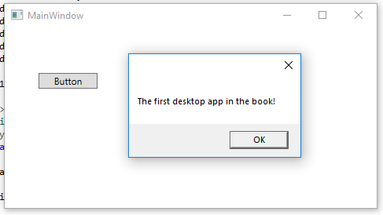

By double clicking the button, the IDE knew that you wanted to write code to execute when a user clicked the button in the running application. The code in MainWindow.xaml (where we added the button) is written in XAML and is the language used to define user interfaces in WPF applications.

|  |  |
| --- | --- |
| **TOPIC** | **KEY CONCEPTS** |
| **Visual Studio 2017 Settings** | This book requires the C# development settings option. |
| **Console Applications** | These are simple command-line applications, used in much of this book to illustrate techniques. Use the console application template in new projects in Visual Studio. |
| **IDE Windows** | Project contents are shown in the Solution explorer window. Properties of a selected item are found in the properties window. Errors are shown in the Error List Window. |
| **Desktop Applications** | Desktop applications have the look and feel of standard windows applications, including the familiar icons to maximise, minimise, and close and application. They are created with the WPF application template. |